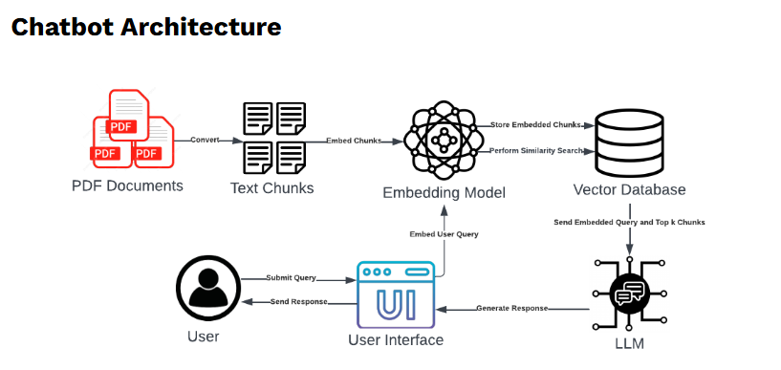

[Building a QA Research Chatbot with Amazon Bedrock and LangChain | Towards Data Science](https://towardsdatascience.com/building-a-qa-research-chatbot-with-amazon-bedrock-and-langchain-677fbd19e3c1/)

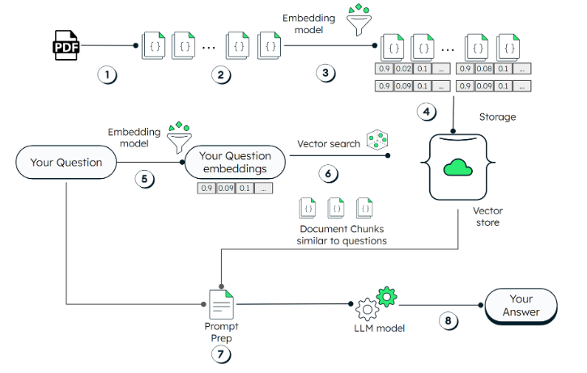

[Building Local RAG Chatbots Without Coding Using LangFlow and Ollama | Towards Data Science](https://towardsdatascience.com/building-local-rag-chatbots-without-coding-using-langflow-and-ollama-60760e8ed086/)